Books
The following are books that were referred to during the 2018 Small Parish Forum
- 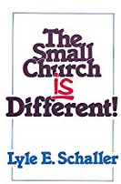 The Small Church Is Different Lyle Schaller 1989
- 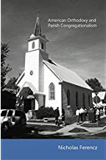 American Orthodoxy and Parish Congregationalism Nicholas Ferencz (Very expensive!)
- 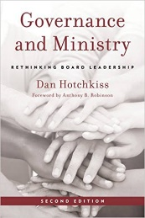 Governance and Ministry rethinking Board Leadership Dan Hotchkiss 2009
- 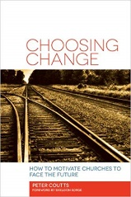 Choosing Change How to Motivate Churches to Face the Future Peter Coutts 2013
- 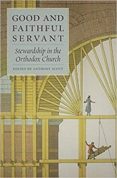 Good and Faithful Servant: Stewardship in the Orthodox Church Edited by Anthony Scott
Also…
- 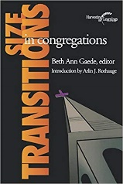 Size Transitions in Congregations
- 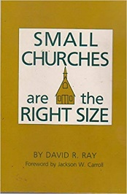 Small Churches are the Right Size

