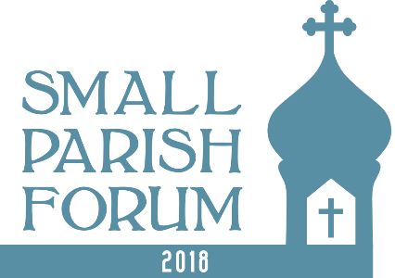
Seventy Quotes and Tidbits:

Small Parish Forum Summary
The following is a compilation of some of the key elements of the sessions at the Small Parish Forum. More info is available on line.
Small Parish Insights
- “Any Parish Can Become Vibrant. All that is required is that its members, beginning with its leaders, be firmly resolved to have it so.” Fr Thomas Hopko quoted in Opening Presentation.
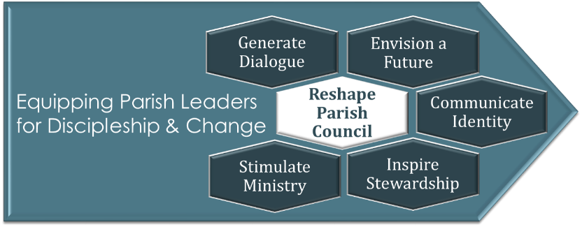
- Small parishes are not malnourished, immature versions of large parishes. They think feel and act different.
- Though “different” they can worship well, care for one another, teach, serve their community and share Christ’s love with others.
- Small parishes need to harness the intimacy and close relationships inherent in their modest size -- AND avoid using their size as an excuse for inactivity and mediocrity.
- There are three paths to small. Those once “large” but now in advanced decline. Plateau parishes that grew a bit, then stalled. Mission parishes that are in early stages and hope to become larger. All need to take different actions. Each requires the ability to discern and to adapt.
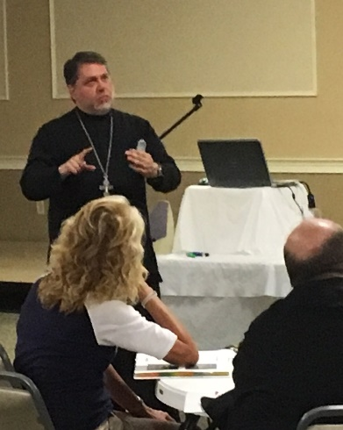
- Of the less good attributes of small parishes, coolness to outsiders, low self-esteem and short tenure of priests are among the most significant.
Foundational/Keynote
- “Churches can work to become storm proof by honest evaluation, clear mission and vision, attainable stretch goals, dynamic outreach, unity in the body and trusted leadership.”
- “Unity in the body and among leaders is the overarching principle in building discipleship and a bright parish future.”
- “Unity is not uniformity. It is unity in mission and vision.”
- Leaders have to be fully committed to be disciples and to make disciples.
Governance Principles
- Congregationalism was a key factor in the structure and governance of early Orthodox parishes in N. America. It exists today in many instances.
- Drivers of congregationalism were: 1) Leadership vacuum (distance from/lack of hierarchs priests) in earliest days of Orthodox parishes 2) Orthodox turmoil (Toth schism; jurisdictional discord) and American secular influences. (Property ownership, “democracy”, separation of powers) American Orthodoxy and Parish Congregationalism Ferencz
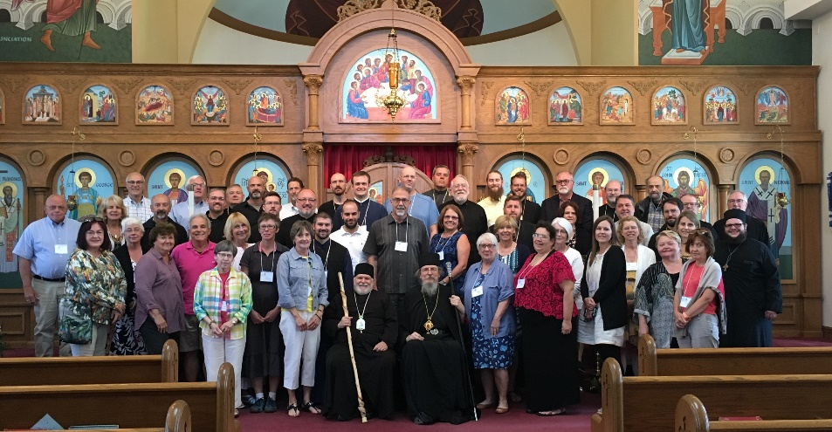
- Congregationalism often resulted in: 1) a sense that the parish exists for “us” (ownership not stewardship), 2) distrust and isolation 3) treating the priest as a hired employee and 4) a sense of independence from the Diocese and Bishop.
- The (proper) Eucharistic/ Conciliar model sees the parish as a constituent part of Diocese which has received its mandate to exist from its hierarch. The parish exists For Christ, to do work of Christ in the world.
- Conciliarity. The consensual unanimity found at the Eucharistic gathering applies outside the liturgy as well. This spirit is opposed to authoritarianism, individualism or democracy. American Orthodoxy and Parish Congregationalism Ferencz
- The Bishop is the source of authority, fullness and unity and stands in the stead of Christ. The priest stands in the stead of the Bishop.
- Clergy and Laity must collaborate and share responsibilities. Both “need each other”. Both are laos: “people of god”
- No separation of spiritual & material. No goal is so purely spiritual that it requires no money, space or time and no action is so financial as to lack ethical or spiritual implications. As a result purview of the parish council is not limited to bills, budgets and buildings, and the domain of the rector is not purely spiritual.”
Parish Councils
- “Most people learn about parish leadership and being on the parish council by observing others. Not always a good, or at least complete, training ground.”
- “I got on the parish council because I saw needs and challenges facing our parish. I wanted to make a difference -- to move us to become more Christ centered. I was frustrated because all they wanted to do is talk about fixing the steps.” Conversation with a lady at a (different –non SPF) conference.
- The key transitions for parish councils are to move from emulating the “parish fire department” –dealing with the urgent – to becoming a shared, inspirational leadership body whose members are seen as exemplars and are actively moving the parish to face forward to a brighter future.
- Parish councils bear the responsibility and the opportunity to move the mission and congregational life into the future. Governance and Ministry – Rethinking Board Leadership, Dan Hotchkiss
- “In the typical long established small church the parish council often functions as a committee of the whole and focuses on details not policy.” The Small Church is Different, Lyle E Schaller
- As a parish grows they need a council that can rise above day to day and think about the bigger picture –not just annually but all the time. Governance and Ministry – Rethinking Board Leadership, Dan Hotchkiss
- “The most important aspect of the Parish Council is that they take seriously the fact that they are actually co-ministers of the Gospel with the clergy and everyone who serves the Church. Everyone in the parish is there to love God and love neighbor, and the Parish Council is as responsible as the clergy and all the laity to make that happen in the parish, to make the parish to be the Body of Christ.” Orthodox priest
- “Not every decision a parish or a parish council has to make requires a seminary degree. But every decision is spiritual in every sense of the word.” Orthodox priest
- “Parish Council’s have essentially three roles. 1) Oversight. To be stewards of God’s resources held in trust by the parish. 2) Vision and Planning. Expressing the total mission of the parish. Articulating a future. Being agents of change and taking intelligent risks. 3) Stimulating Ministry. Defining an appropriate set of ministries. Structuring the parish to empower ministry. Encouraging accountability.”
- “The optimum size of a good parish council is 6-8 persons.”
- Ideally a parish council would include a balance of generative/conceptual thinkers – people who find and conceptualize opportunities and operate with a longer focal length – and implementers – people who define practical solutions and get things done. Both are important.
- “Parish Council members have three fiduciary duties. 1) Duty of care. Act with the diligence and skill of an ‘ordinarily prudent person under similar circumstances.’ 2) Duty of Loyalty. Act with faithfulness to best interests of parish. Avoid potential conflict of interest 3) Duty of Obedience. Act consistent with central parish goals. Follow laws by-laws, parish policies.”
Meetings
- “Parish council meetings are the primary place where the parish council fulfills its duties. Yet parish council meetings are historically unproductive and sometimes contentious. If they are important, why do we invest so little time learning and working toward producing positive and productive meetings?”
- “Select a future meeting date to discuss how your group meets, how you speak with one another, how decisions are made, and whatever else you want to discuss related to the culture of your group.”
- Poor Meetings: Start/end late; boring; little accomplished; overbearing personality; generate hard feelings; rehash past discussions.
- Good Meetings: Great discussion; seem shorter than actually are; energy; learning; personal growth; many contributors; decisions, consensus on future direction.
- “Typical parish council meetings deal with transmission of information, “money” and short term details all in the context of an unchanging monthly agenda. To move the parish toward a brighter forward consider a different style of meeting emphasizing: 1) Participation and action 2) Strategic & generative thinking; 3) A variable monthly agenda 4) Setting aside time for long range topics.”
- “Dialogue: Greek: for making meaning through words. Goal: understanding. Dialogue practices: Suspend judgement; encourage everyone to speak, speak to the center” (i.e avoid “cross-talk” - one member of the group disrupts the dialogue process to offer commentary or opinion regarding someone else’s opinion).”
- “Discussion: Latin for “shake apart”. Goal: form a decision. Strive to avoid a “win-lose” model.”
- “Effective meetings blend dialogue and discussion/decision making. Know the difference. Identify agenda items as either topics for ‘dialogue’ or ‘discussion/decision’.”
- “When a potentially controversial or challenging topic arises, consider using one meeting to dialogue and the next meeting to discuss. This provides time for participants to consider all perspectives, be better prepared to discuss, and therefore reach a decision.”
Mission/ Vision/ Values
- “Churches live in present or past but rarely talk about the future. Yet every parish, even the most vibrant ones, are at a hinge point. They can “grow” (qualitatively or quantitatively), they can stagnate/decline. Status quo is not a real option for any parish in N. America.”
- “A mission statement is your opportunity to define your parish goals, ethics, culture, and norms for decision-making. It expresses the parish’s reason for existing and is a written declaration of the parish’s core purpose and to answer questions about ’what do we do’ and ‘what make us different.’”
- “A parish vision is a sensible, practical and appealing picture of the future usually described in the context of a specific time horizon. (5 years; 10 years etc.) Imaginable. Desirable. Feasible. Focused. Flexible. Communicable in less than 5 minutes.”
- “Values are consistent, passionate, scriptural, distinctive convictions that determine our priorities, influence our decisions, drive our ministry and are demonstrated by our behavior.”
- “To be useful, parish values need to be: 1) expressed, 2) holy 3) shared and 4) lived.”
- “One “apophatic” approach to discerning values is to answer the question “what are we against?” What behaviors, characteristics or attitudes are we unwilling to put up with here?”
- “Discernment does not operate on a knowable timetable. Allow vision development to take the needed amount of time, despite the reality that there will be those in the parish who will be anxious to get to the ‘answer’ and know what to ‘do.’”
Change
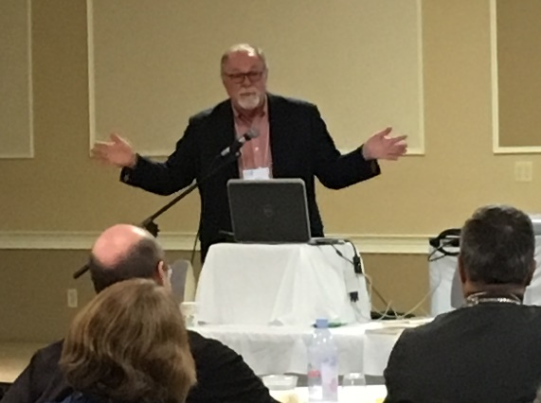
- “Change is at the heart of any parish’s life. It must be conceived carefully. Introduced transparently and purposefully and justified beneficially.” Keynote
- “Trust is the key to change.” Keynote
- “People can change. In particular they are motivated by success.” Keynote
- “Important tactics of change are: 1) Committed core group –respective, trusted, diverse. 2) Face facts. Start with honest self-evaluation. 3) Focus. You can’t change everything at once. Select one key area. 4) Understand the Change Environment. What are sources of resistance? Compelling reasons in favor of change. Who will be early adopters? 5) Commit and Communicate. Define a clear picture of where we’re going. Explain the benefits of change and “what’s in it for me”. Communicate this. A lot.”
Supporting Clergy and Their Families
- “Lay leaders, take care of your priest and their families so they can best serve you, because this is what they truly want to do.”
- “Never assume you know everything about clergy family dynamics. Because you don’t.”
- “DO NOT listen to or add to stories (gossip) that travel around. Unfortunately, people seem to have the need to analyze, place blame and shame.”
- “Clergy families take many risks. They open their hearts to new people. They invest everything they have in a community – often far away from family.”
- “Even when everyone does everything right, some situations are not healthy ones for a clergy family. And that should be ok. The only requirement should be that when you fall, get up. It is fine to ask for help in getting up.”
- “NEVER COMPARE with others. Specifically, never compare your priest or your priest’s family with former priests or your parish to other parishes. This only leads to bad things.”
- “Take care of yourselves to always remain teachable, grow and be healthy. And make sure your priest does this. If the priest and his family aren’t healthy, they can’t take care of others. Remember to “put on your own oxygen mask first before you assist others.”
- “Remember the big picture. Leaders, clergy and laity, build on the foundations of others. Those who came before us did the best they could with very little and often under trying circumstances. Do not criticize or belittle past efforts. Prepare for others to take up the reins. Pass the gift along confident that those who follow us will accomplish even greater things.”
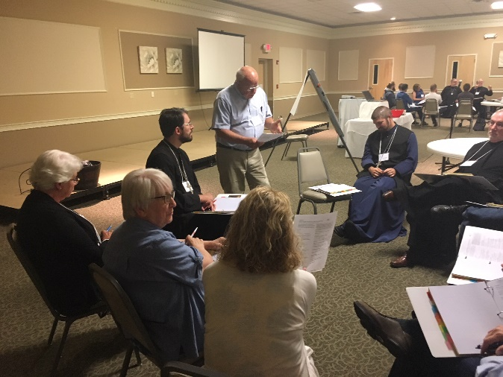
External Communication and Parish Identity
- “In an age of rapidly proliferating communication technologies, it is urgent for parishes to consider how and what they are they are communicating.”
- “How many people living within two miles of the parish could say something accurate about the parish? How many know our parish for our food, rummage sales, craft fair etc. as opposed to our Gospel centered ministries?”
- “Of course our parish identity is rooted in the Orthodox faith. Nonetheless just as individuals are different and have different gifts; so it is with parishes. Understand and communicate that unique particular identity.”
- “Websites help us to be (efficient) fishers of men. Webstats mean nothing if people don’t ‘come and see’.”
- “Websites are more important for an Orthodox parish since: 1) Orthodoxy is not well known 2) Technology levels playing field – ‘Helps little guys look big’. 3) Orthodoxy offers high uniqueness –much to communicate. 4) Orthodox Christianity is highly photogenic. “
- “To a great extent church selections are made based on “atmosphere” & “people”. So… show people … & atmosphere. Beauty and joy.”
- “Tips for better parish images. 1) Tell the Story! - Always photograph the setting. 2) Include different age groups. 3) Use light & shadows to convey the mystery. 4) Capture the spirit of the moment --the joy of Pascha… the intensity of Great Lent. 5) Follow the Feasts to express a diversity of special moments!”
- “Using personal narratives on your website – brief written or video stories from parishioners about their Christian journey and their relationship to the parish – can help to define an ‘attractive parish personality’ and help inquirers feel like they can find ‘people like me’.”
- “In a survey of Orthodox persons who embraced the faith as adults (converts), the most significant obstacle they faced was not theological but rather the ethnic qualities of the parish.”
- “The ethnic feel of Orthodoxy can give the impression that Orthodoxy is more about culture than the gospel.” Survey respondent”
- “Orthodox Christianity in America abounds with stereotypes. (Culture club; foreign language; closed to outsiders; don’t know bible; complex etc.) Some are accurate. Many are not. Often gracefully confronting wrong stereotypes can be important and helpful. Websites can do this with images text and an appropriate interface structure that helps inquirers explore.”
Small Parish Development Grants
- One or two small parish development grants of ~ $2,000 will be awarded to attending parishes to fund a new or expanded effort or ministry.
Thank you for attending.

