Orthodox Church in America
Archdiocese of Western Pennsylvania
Diocese of the Midwest
Bulgarian Diocese
2018
Parish Development Grant Application

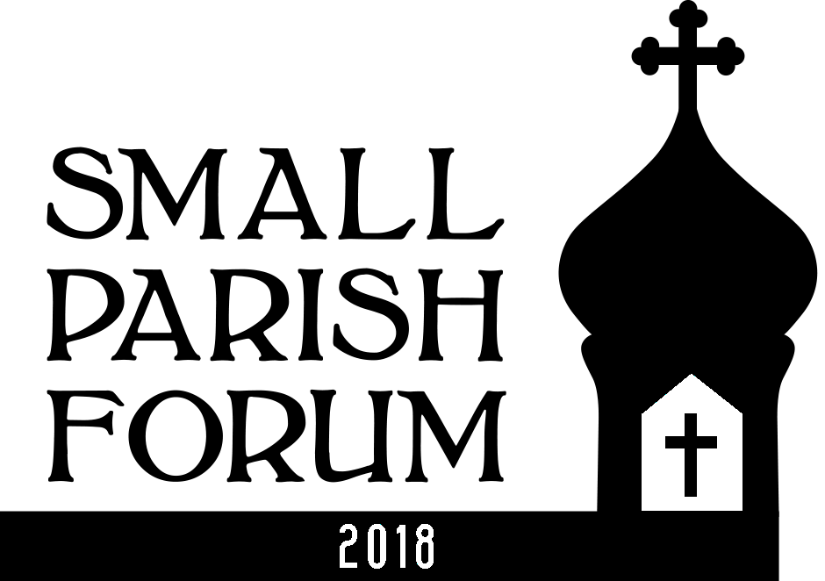

2018
Small Parish
Development Grant Application

Small Parish Development Grant Initiative

2018 Small Parish Development Grant Application

Applicant Information

Information on Parish Applying for the Grant
Parish Name
Parish Address
City State Zip Code
Parish Website address
OCA Diocese (or Orthodox jurisdiction if other than OCA)

Contacts

Priest
Priest Name Priest Phone Priest Email

Primary Contact (if other than the priest)
Information about a layperson that who will be the primary contact if other than the priest.
Name Address
Daytime Phone Evening phone Email address

Grant Project Information

Description of Project for Which You Are Seeking a Grant

Project Name
Type a descriptive name for the project. (~ ten words or less)

Need
Describe the problem you are trying to solve or impact or the opportunity/situation you are trying to address. Why is this effort relevant to the future vibrancy and vitality of your parish? Does this effort shore up a perceived strength of your parish? Is it aimed at a weakness?

Objectives
Describe the key objectives of the project. Measurable objectives are desirable-- but sometimes impossible.

Description
Provide a description of your project. What is this effort/project about and what will you do? Describe how your parish will be involved. Will 2-3 people or many be involved?

Project Category
Which category(s) of parish life that will be impacted by your project? Check all that apply.

Campus Outreach
Charitable Outreach
Communication
Education
Evangelization
Fellowship
Leadership
Stewardship Development (financial or other)
Worship
Youth
Other (describe).
Describe
Please do not submit projects that deal with facilities upgrades/ improvements.

Steps/Plan/Probability of Effective Execution
What are the primary steps associated with executing this effort? Make this only as complicated as it needs to be and no more. We simply want an indication that you have thought this through to an appropriate degree.

- (Continue in this box if more steps are necessary.)

Ability to Execute
Can you really do what you propose and do it effectively? Use the box below to describe your ability to get this done.

Costs
Are there out of pocket direct costs associated with this project? How much are they? What are they for?
Note: Grant projects do require serious effort on the part of parishioners. Grant projects do not require that parishes incur direct costs. In the case of projects without direct costs the grant monies can be used to support other parts of the parish budget.
No costs associated with this grant request.
There are costs associated with this grant request.
If you checked the above box indicate the estimated amount of cost associated with this grant in the box below:
Item/Cost category | $ Amount
 | $
 | $
 | $
 | $
 | $
Total | $
Anything else to say about costs?

Grant Amount Request
Indicate the total $ amount you are requesting. (Target grant size is $2000.
We are requesting $ .

Impact
Use this section to describe the impact this project could have on your parish and/or the local community (neighborhood). Indicate the potential timeframes in which results might be realized or when the project outcomes can be assessed.

To Your Parish
Describe how you hope this effort will positively impact the life of your parish. This is required.

How soon might you see these outcomes/impact? How do you propose evaluating these outcomes?

To Your Community/Neighborhood (Outside of your Parish)
This is optional. It is hoped that many projects will look outside the parish to bring the light of Christ to your community. However, strictly internally focused projects are perfectly acceptable.
If applicable, describe how you hope this effort will positively impact the neighborhood or community.

How soon might you see these outcomes? How would they be evaluated?

Deadline October 15, 2018
Submit this application electronically (via email) to joekormos1@gmail.com
For information call Joe Kormos 513.683.1911
IF YOU DO NOT RECEIVE A CONFIRMATION Email from Joe Kormos Please contact him.
IT IS YOUR RESPONSIBILITY TO BE SURE THE APPLICATION IS RECEIVED.

