Parish Development Ministry Report
  - Joe Kormos Archdiocesan Assembly , 2019
The following are a few highlights from 2019.

Parish Development Forum -- Canonsburg PA
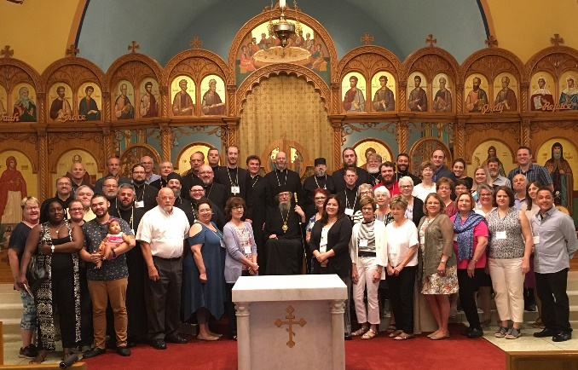
The 2019 Small Parish Forum took place from 3PM Thursday July 11 thru noon on Saturday July 13 at St. John the Baptist Church in Canonsburg. Theme was Strengthening Our Commitment to the Community: Growing and Sharing Our Faith; Welcoming Others.
This year the Forum was re-labeled “Parish Development Forum” from the previous “Small Parish Forum”. The change seems to have worked out well.
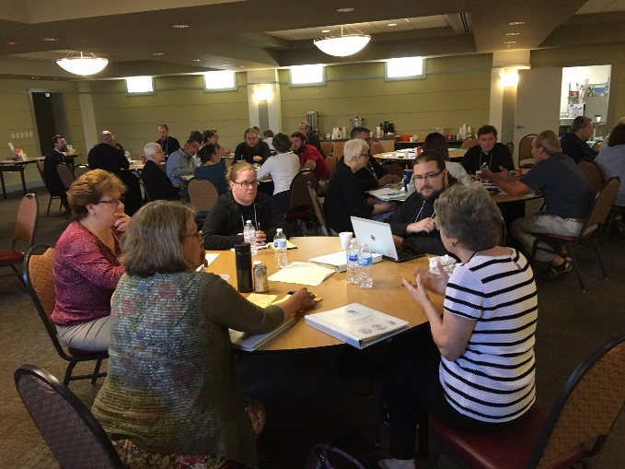
Total attendance was 62 persons. This included attendees from the sponsoring Dioceses --Archdiocese of Western PA, Midwest and Bulgarian, as well as OCA Dioceses of NY/NJ, South, and New England and parish development specialists from the Greek and Antiochian Archdiocese.
Eight speakers contributed to the Forum including keynote presenters Father Paul Abernathy and Father Maximus Urbanowicz. The agenda included a review of the movie “Becoming Truly Human” and a panel discussion featuring Orthodox converts.
All materials are posted online on the Parish Development/ Parish Forum page.
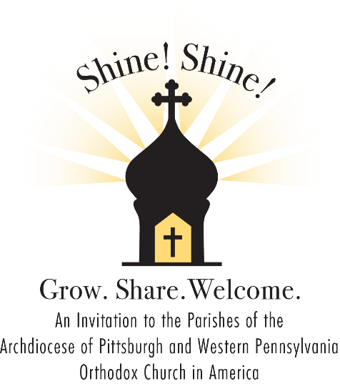
Suggestions were made to change the dates of the Forum from early July to an autumn time frame to avoid vacation conflicts. After discussing this with the Forum planning group it was determined that autumn dates often have conflicts with various events in sponsoring Dioceses –assemblies and others -- so the Forum will remain as a summer event.

Shine! Shine! Initiative
Our Parish Development Committee has met in person one time and multiple times via online meetings.
Each parish has been asked to define and undertake a “project” based on the theme ‘Building a Bright Parish Future: Growing in Faith; Sharing Our Faith; Welcoming Others.”
A webinar was held to explain the initiative in mid-May.
Registrations of parish projects have been slow in coming but are now picking up momentum.
Joe Kormos is available to assist parishes in exploring potential projects and assisting with projects.

Hospitality Video
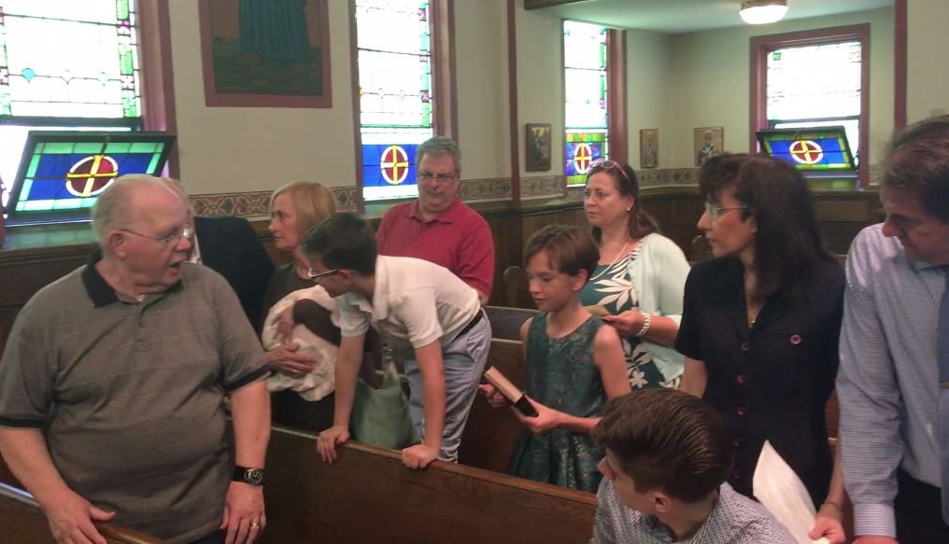
As part of the Shine Shine Initiative a home-made video was created in conjunction with the Parish Life committee at Holy Ghost parish in Ambridge which parodies typical faux pas that occur when parishes welcome (or don’t welcome!) visitors/inquirers/children to their church. The video is available on YouTube under a private link. The video includes discussion questions for use in a parish class, coffee hour or parish life committee.

Parish Visits/Workshops
As a reminder we are willing and available to work individually with parishes on particular workshops or projects. These can be via online meetings, parish visits or ongoing telephone/email interaction. Topics might include: stewardship, vision and planning; parish administration; leadership; outreach and evangelization and others.
First step is to call.

Speaking Engagements and Interjurisdictional Projects
While not of direct impact on parishes of the Archdiocese, we have recently been invited as the featured speaker for the Assembly of the OCA Diocese of the South, held in Port St Lucie FL in July as well as the Greek Orthodox Archdiocese Metropolis of Pittsburgh Clergy Laity Conference held recently in Harrisburg. Both were extremely effective events and shined a positive light on the ongoing efforts of our Archdiocese to build brighter futures for parishes.
Of perhaps greater direct impact is a video project being undertaken by the GOA as a continuing education tool for clergy and lay leaders. A series of eight 60 minute videos – each divided into 15 minute chunks - is planned. We recently traveled to the GOA seminary in Brookline MA to film the initial video: “What is a Healthy Parish; How Do We Assess Parish Health?” The presentation is based on the Archdiocese’s Parish Health Inventory model.
Other topics will include: Healthy Leadership; Parish Identity and Culture to name a few. All other speaker/contributors appear to be from within the GOA.
Once completed, these videos will be available for use in Archdiocese of Western PA parishes.
In Christ,
Joe Kormos
cell 513-518-5878
Joekormos1@gmail.com

