Potential Parish Improvement Initiatives

Small Parish Forum 2017

Background
We have found that attendees at the Small Parish Forum return to their parishes with intentions to strengthen existing efforts or start new ones. Then, after a few months –or less, effort fades and little happens.
There are many root causes. One of them is not having a clear sense of what seems to be the best area of focus for the parish. This leads to broad conversations leading to … nowhere. During the 2017 Forum we will try to guide/encourage each parish (whether you’re a group or a single attendee) to select a particular initiative to recommend/act upon after returning home.
In addition to selecting a specific initiative –we can help you to flesh this out while at the Forum – the Forum team is willing and available to follow-up with you at select intervals after you return to assist you in keeping things moving.
The following are some suggested initiatives. You of course are free to choose/design your own.

Possible Projects

Vision/Identity
- Develop a written Vision/Mission statement for the parish.
- Complete the Parish Development inventory survey as a parish. Report results and plan a next step.
- Survey parishioners "What do we value"? Do we live what we say we value? How to improve?
- Plan a long term (3yr.) budget. Summarize your critical assumptions. What does this say about us?
- Survey parish neighbors. "Who are we?" “What do you know about us?”
- Conduct a survey/series of conversations of some form asking parishioners: ‘What are the important qualities we want to develop in our parish in the next 5 (or 10) years?’ What does a parish that is bringing Orthodoxy to N. America need to be good at?
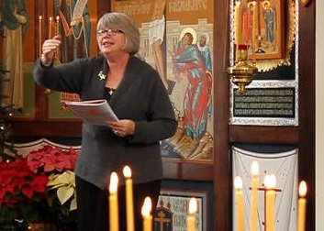
- Establish via parish wide dialogue two or three important parish priorities. Perhaps one related to facilities, one internal development, and one external outreach.

Worship
- Make an honest renewed commitment to improved liturgical music. (Various sorts of efforts)
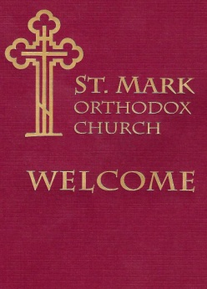
- Learn a “chunk” of new music (new versions, singing support for additional service beyond Divine Liturgy)
- Begin serving vespers/feast day services (if not previously served)
- Implement congregational style singing if appropriate or necessary.
- Obtain a pledge from a core group to attend vespers/feast day services by large segment of parish
- Plan and implement a “Greeter's ministry” along with a welcome packet
- Guest follow up ministry. They came once –now get ‘em to return.
Folder for Welcome Packet
- Liturgical aids --liturgy or vespers books
- Feast day sponsors – Have families or parish organizations sponsor particular feast days: decorate; special meal.
- Mystery Worshipper – Engage 2-3 unknown persons to attend your parish for 3-4 weeks. Summarize/share their reactions. Make necessary changes.

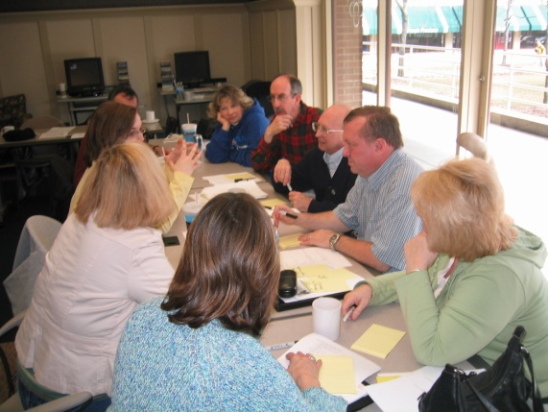
Leadership
- Clarify/update role definition for parish council
- “Grade your Parish Council Paper” – Thoroughly review and evaluate the performance of parish council/board. What are you good at? Not good? What holds you back? Is last year’s #1 problem still today’s problem? Too much time on triviality? Do you build urgency? Promote excellence? Model good behavior? Generous? Nattering bobs of negativity?
- Establish/clarify parish administrative policies – in writing. Improve/modernize this if needed.
Often a leadership body's most effective action is a self evaluation
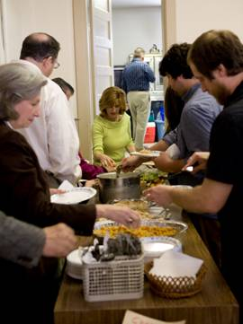
- Review existing set of parish ministries: stop; start; continue. Analyze what % target current members, what % target unchurched? Fallen away members; % with an evangelistic component?
- Conduct an annual Parish Council planning retreat.
- Hold a leadership conversation and find an important risk that your parish should take to strengthen its future. Then generate the leadership strength to do it.
- Survey parish buildings and property with a critical eye to finding shabby areas. Commit to fix one or two this year.

Community
- Commit to regular coffee hour – fellowship every Sunday!
Fellowship - the Liturgy after the Liturgy
- Create an updated "membership" responsibilities document/manual. What does it mean to be a member of the Body of Christ? What is expected of us?
- Create a specific “assimilation/new member integration ministry” –help welcome/orient new persons. Help them find friends/find a role. A team that thinks, dreams, and breathes new ministry for members!
- Break up seemingly impenetrable groups during coffee hour; Re-form new social relationships.
- Parish Photo Contest – Invite each parish group; persons to capture their Life in Christ – expressing your parish’s vibrant personality.
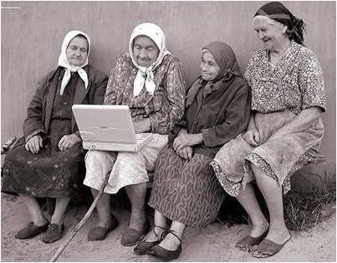
- Parish Stories Project – Most parishes have a strong heritage and important stories that shouldn’t be lost. Capture, summarize the stories –written and video. What do these stories mean to us as we embark on our next hundred years of life?

Communication
- Build a parish email list. Commit to using it regularly. Bring the church to them more than on Sunday
- Build an accurate, up to date parish address, phone, photo directory.
Email is everywhere; every generation!

Formation/ Prayer
- Adult Ed. -- Begin/ reinvigorate a Parish Adult education effort. Analyze causes of past failures. Fix.
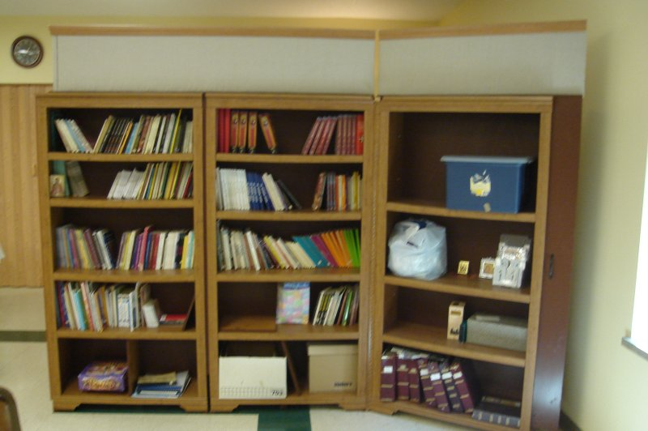
- Needs Audit - Conduct a faith education audit. Identify key segments of parish population (seniors, parents, teens etc.) and determine what their formational status and needs really are. Offer something that fits one or more target groups.
- Bible study -- perhaps in neighborhoods where parishioners live
- Orthodox Book reading list -- Create a reading list of books about the Orthodox faith.
Movable Library
- Orthodox discussion group – book club -- inviting non Orthodox
- Parish Book reading challenge: small groups – Conduct a book reading contest – which parish club or ministry can read the most books over six month period?
- Establish a parish library or bookstore.
- Series of monastery pilgrimages – Plan a series of visits to monasteries.
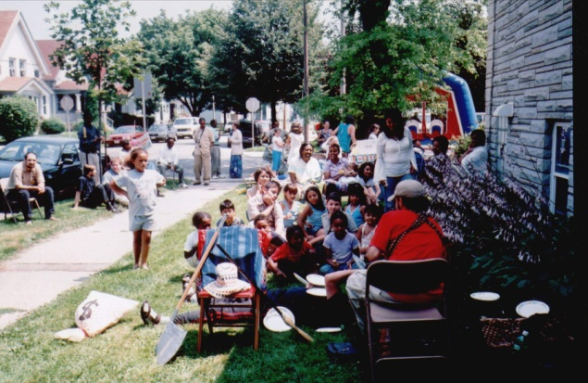
- Develop a thank you system for your parish.

Stewardship
- Eliminate dues – Decide now to eliminate dues as your parish stewardship approach.
- Implement pledge system.
- Personal budgeting training class – invite neighbors.

Active Service
- Commit to give a significant % of fund raising $ to charity
Parish Sponsored Block Party
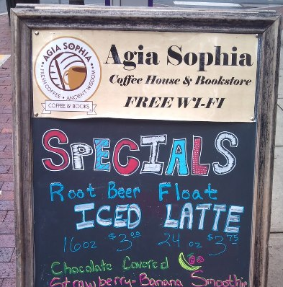
- Begin an active local charitable effort – one that involves a commitment of time from parishioners. (E.g Monthly effort @ Soup Kitchen)
- Add a charitable donation line item to the parish budget. Commit to achieve a target % of for charity after x years.
- In reach ministry to help parishioners in need.
- Neighborhood Block Party – Plan a Saturday of games/fun for neighborhood Youth.
Spreading the Gospel
- Implement a decent parish website; new or improved
Agia Sophia Coffee House Harrisburg PA
- External event series (e.g. lectures, films) for inquirers.
- Parish speaker's bureau.
- PR effort with local newspaper.
- "What not to do when guests arrive" video – create a humorous video identifying the wrong ways to welcome people to our parish. What are our growth limiting behaviors?
- Update Orthodox Church listings at nearby hotels to identify your parish.
- Buy Orthodox books for local library with parish name inside.
- Parish yard signs and/or bumper stickers (“Honk forty times if you’re Orthodox”)

